Encryption and Decryption

# =========================================================
# MODULE 2 — Decrypt an encrypted message (Linux commands)
# Assets, Threats, and Vulnerabilities
# =========================================================
# ---------------------------------------------------------
# Task 1: Read the contents of a file
# ---------------------------------------------------------
# List files in the home directory
ls /home/analyst
# Read the instructions in README.txt
cat README.txt
# ---------------------------------------------------------
# Task 2: Find and decrypt a hidden file
# ---------------------------------------------------------
# Change to the caesar subdirectory
cd caesar
# List all files, including hidden files
ls -a
# View the contents of the hidden file
cat .leftShift3
# Decrypt the Caesar cipher (left shift by 3)
cat .leftShift3 | tr "d-za-cD-ZA-C" "a-zA-Z"

# Return to the home directory
cd ~
# ---------------------------------------------------------
# Task 3: Decrypt the encrypted file
# ---------------------------------------------------------
# Decrypt the encrypted file using the revealed OpenSSL command
openssl aes-256-cbc -pbkdf2 -a -d -in Q1.encrypted -out Q1.recovered -k ettubrute
# Confirm the decrypted file exists
ls
# Read the decrypted message
cat Q1.recovered

Activity overview
As a security analyst, you’ll need to implement security controls to protect organizations against a range of threats.
That’s where hashing comes in. Previously, you learned that a hash function is an algorithm that produces a code that can’t be decrypted. Hash functions are used to uniquely identify the contents of a file so that you can check whether it has been modified. This code provides a unique identifier known as a hash value or digest.
For example, a malicious program may mimic an original program. If one code line is different from the original program, it produces a different hash value. Security teams can then identify the malicious program and work to mitigate the risk.
Many tools are available to compare hashes for various scenarios. But for a security analyst it’s important to know how to manually compare hashes.
In this lab activity, we’ll create hash values for two files and use Linux commands to manually examine the differences.
Code:
# MODULE 2 — Create hash values (Linux commands)
# Assets, Threats, and Vulnerabilities
# =========================================================

# ---------------------------------------------------------
# Task 1: Generate hashes for files
# ---------------------------------------------------------

# List the contents of the home directory
ls

# Display the contents of file1.txt
cat file1.txt

# Display the contents of file2.txt
cat file2.txt

# Generate a SHA-256 hash for file1.txt
sha256sum file1.txt

# Generate a SHA-256 hash for file2.txt
sha256sum file2.txt

# ---------------------------------------------------------
# Task 2: Compare hashes
# ---------------------------------------------------------

# Generate the hash for file1.txt and save it to file1hash
sha256sum file1.txt >> file1hash

# Generate the hash for file2.txt and save it to file2hash
sha256sum file2.txt >> file2hash

# Display the contents of the hash files
cat file1hash
cat file2hash

# Compare the two hash files byte by byte
cmp file1hash file2hash
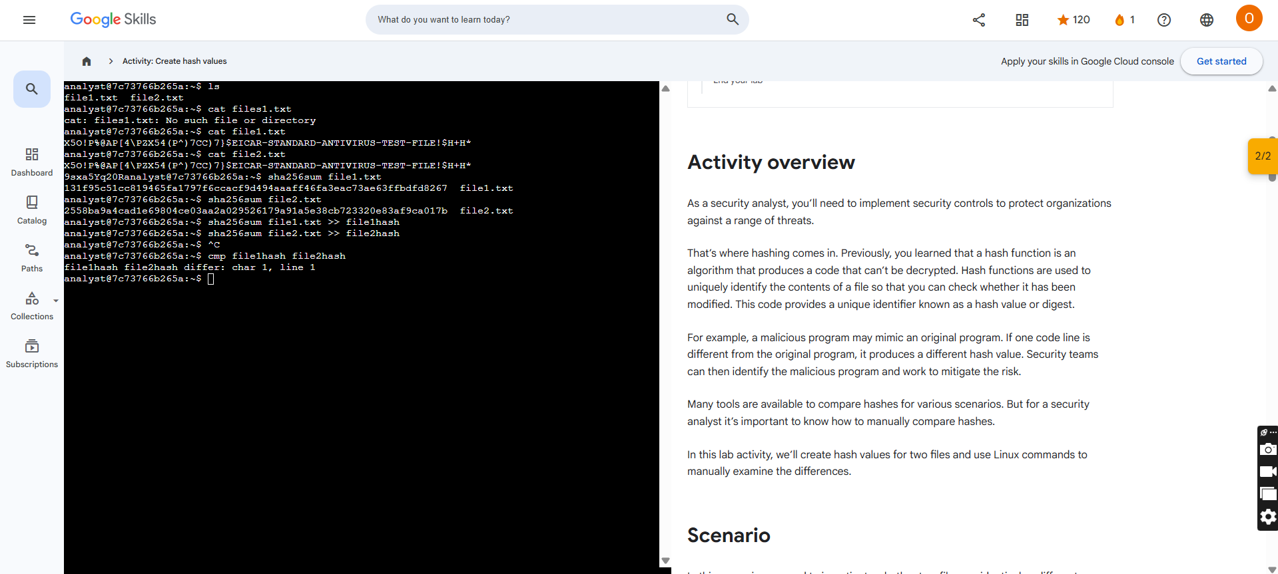

Activity Overview
In this activity, you will assess the access controls used by a business. You’ll analyze their current process, identify issues, and make recommendations to improve their security practices.
Previously, you learned that access controls are security controls that manage access, authorization, and accountability of information. Authentication controls are used to verify who someone is, whereas authorization controls are used to grant a user permissions and set limits on the things they’re allowed to do. When done well, access controls are the key to decreasing the likelihood of a security risk.
Be sure to complete this activity before moving on. The next course item will provide you with a completed exemplar to compare to your own work.

Scenario
Review the scenario below. Then complete the step-by-step instructions.
You’re the first cybersecurity professional hired by a growing business.
Recently, a deposit was made from the business to an unknown bank account. The finance manager says they didn’t make a mistake. Fortunately, they were able to stop the payment. The owner has asked you to investigate what happened to prevent any future incidents.
To do this, you’ll need to do some accounting on the incident to better understand what happened. First, you will review the access log of the incident. Next, you will take notes that can help you identify a possible threat actor. Then, you will spot issues with the access controls that were exploited by the user. Finally, you will recommend mitigations that can improve the business' access controls and reduce the likelihood that this incident reoccurs.

Step-By-Step Instructions
Follow the instructions and answer the question below to complete the activity. Then, go to the next course item to compare your work to a completed exemplar.
Step 1: Access the template
To use the template for this course item, click the link below and select Use Template.
Link to template: Access control worksheet
OR
If you don’t have a Google account, you can download the template directly from the attachment below.

Step 2: Access supporting materials
The following supporting materials will help you complete this activity. Keep them open as you proceed to the next steps.
To use the supporting materials for this course item, click the link below and select “Use Template.”
Note: The spreadsheet for this supporting resource has two tabs.
Link to template: Accounting exercise
OR
If you don’t have a Google account, you can download the supporting materials directly from the attachment below.

Step 3: Review the event log of this payroll incident
Event logs contain information related to the operation and usage of a system. They can be utilized to identify suspicious activity, detect vulnerabilities, and track users.
Find the Event log tab of the Accounting exercise spreadsheet. Carefully review the event log of this incident to start your investigation. Notice the Event Type, Date, Time, and IP Address of the user in the log details.
Make 1-2 notes of information that you learned about the user from reviewing the Event log details. Add your notes to the Notes column of the access control worksheet.

Step 4: Identify access control issues that led to the incident
Log details tell you a lot about a specific moment in time. You can find other useful details about an event by cross referencing that information with other sources.
This business has a range of different employees. They all currently manage company resources using a shared cloud drive.
Find the Employee directory tab of the Accounting exercise spreadsheet. Compare the information found in the Employee directory tab with the information in the Event log tab. Notice any similarities between the details in the Event log and the details in the Employee directory.
Then, list 1-2 issues that you discover with how the business handles employee access in the Issues column of the Access control worksheet.

Step 5: Recommend mitigations that can prevent a future breach
You’ve completed your accounting of the strange payment and discovered flaws with how the business handles their information.
Find the Recommendation(s) column of the Access control worksheet. Make at least 2 recommendations of mitigations the business can implement to prevent incidents like this in the future.
For example, one recommendation might be to have procedures in place to revoke access to files when an employee is no longer with the company.

What to Include in Your Response
Be sure to include the following elements in your completed activity:
- 1-2 notes about the user
- 1-2 access control issues
- 2 recommendations for access control mitigations
Result of analysis
